TITLE: PC build Recommendation System (Web-based)
Group Members: Umer Daraz and Kashif

Milestone | Version | Remarks
- ERD Schema | 1.0 | Approved
2) ERD Schema | 1.1 | Changes Accomodated

ERD DIAGRAM

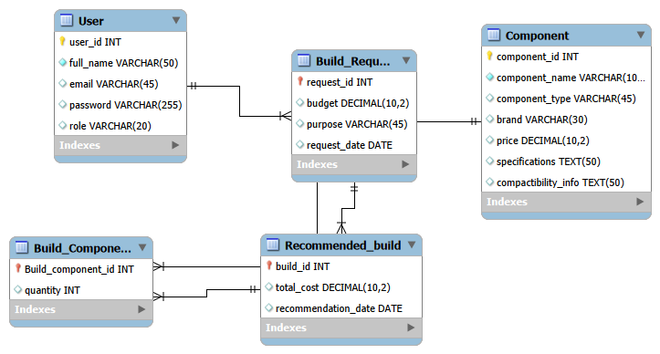

Relational Database Schema Description:

1. User
Attribute | Datatype | constraints
user_id | INT | Primary key
full_name | Varchar(50) | Not null
email | Varchar(50) | Not null,unique
password | Varchar(100) | Not null
role | Varchar(20) | Not null

2. Build_Request
Attribute | Datatype | Contraints
request_id | INT | primary key,not null
budget | decimal(10,2) | not null
purpose | Varchar(45) | not null
request_date | DATE | not null
user_id | INT | FOREIGN KEY → User(user_id)

3. Component
Attribute | Datatype | Contraints
component_id | INT | Primary key
component_name | Varchar(45) | Not null
component_type | Varchar(45) | Not null
brand | Varchar(45) | Not null
price | Decimal(10,2) | Not null
specification | TEXT | -
compactibility_info | TEXT | -

4. Recommended_Build
Attribute | Datatype | Contraints
build_id | INT | primary key,not null
total_cost | Decimal(10,2) | not null
recommendation_date | DATE | not null
request_id | INT | FOREIGN KEY → Build_Request(request_id)
component_id | INT | FOREIGN KEY → Component(component_id)

5. Build_Component
Attribute | Datatype | Contraints
build_component_id | INT | Primary key
quantity | INT | not null
build_id | INT | FOREIGN KEY → Recommended_Build(build_id)
component_id | INT | FOREIGN KEY → Component(component_id) (inferred)

Relationships Summary:
Relationship | Type | Description
User → Build_Request | One-to-Many | One user can submit many build requests
Build_Request → Recommended_Build | One-to-Many | One request can have many recommended builds
Component → Recommended_Build | One-to-Many | One component can appear in many recommended builds
Recommended_Build → Build_Component | One-to-Many | One recommended build can contain many build components

